1. **You own a car dealership and are trying to decide how to configure the showroom floor. The floor has 2000 square feet of usable space. You have hired an analyst and asked her to estimate the NPV of putting a particular model on the floor and how much space each model​ requires**

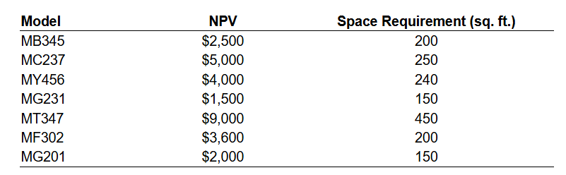

**In​ addition, the showroom also requires office space. The analyst has estimated that office space generates a NPV of $14 per square foot. What models should be displayed on the floor and how many square feet should be devoted to office​ space?**

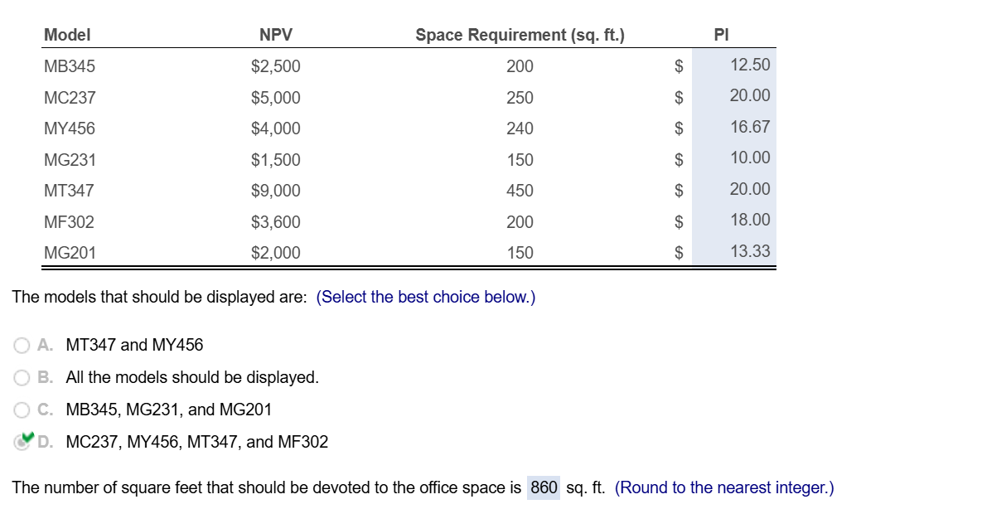

1. **Your success in business thus far has put you in a position to purchase a house for ​$499,000 located close to the university you attend. You plan to pay a down payment of ​$98,000 and borrow the remaining $ 401,000. You need to decide on a​ mortgage, and realize you can apply the skills you have acquired in the last several chapters to evaluate your choices. You are considering a 30​-year ​fixed-rate mortgage. You begin by looking on a web site like** [**www.bankrate.com**](http://www.bankrate.com) **for all the choices available in your location. As you will quickly find​ out, loans come with different ​"points"long dashfees that your must pay at loan origination. You want to determine the most attractive option at each point level​ available, including loans with zero points if they are available.**

**You recorded the interest​ rate, points,​ fees, "APR," and monthly payment for each loan in the following​ spreadsheet:**

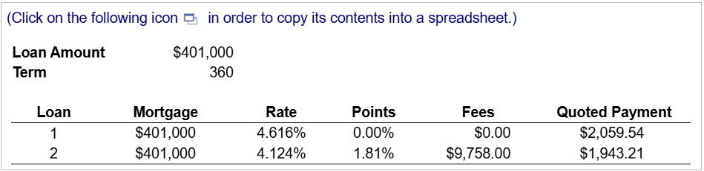

**You used the annuity formula or PMT function in Excel to verify the monthly payment for each loan.​ (Note that to convert the quoted interest rate to a monthly interest​ rate, you must divide by 12. Your result may differ slightly due to​ rounding.)**

**​Next, calculate the actual amount you will receive from each loan after deducting fees.​ (Note that fees include both closing costs and points. Points are paid up front and are calculated as a​ % of the loan​ amount.) Using this net amount as the amount you will receive​ (rather than $ 401,000​), show that the quoted​ "APR" of the loan is the effective IRR of the loan once all fees are included​ (you may use the annuity calculator available in​ MyFinanceLab, the RATE function in​ Excel, or calculate the NPV at the quoted​ "APR").**

**Start by assuming you will take the lower point loan. Now consider the decision to switch to the higher point loan.**

**1. Compute the incremental cash flows of taking the higher point loan instead of the lower point​ loan; that​ is, determine how much more you will pay in​ fees, and how much you will save on your monthly payment if you choose to switch to the higher point loan.**

**2. What is the payback period of the higher point​ loan? That​ is, how many years of lower monthly payments will it take to save an amount equal to the higher​ fees?**

**3. What is the IRR associated with paying the higher fees for the lower rate​ loan? (Again, the annuity calculator or the RATE function can be used. If you have trouble calculating the​ IRR, it may not​ exist, which will become evident when you plot the NPV profile in ​(4​)).**

**4. Plot the NPV profile of the decision to pay points for the lower rate loan. Do the NPV rule and the IRR rule​ coincide?**

**​Next, compare the loans assuming you expect to keep them for only five​ years:**

**5. Compute the final payment you will need to make to pay off each loan at the end of five years ​(Hint​: the FV function in Excel can be​ used). Which loan will be more expensive to​ repay?**

**6. Including the incremental cost to repay the loan after five​ years, what is the IRR associated with paying points​ now?**

**Create a data table showing the NPV of paying points for different horizons​ (1 to 30​ years) and different discount rates​ (0% to the IRR in ​(3​) ​above). What can you conclude about whether it is a good idea to pay​ points?**

**Suppose the bank gives you the option to increase either loan amount so that for either​ loan, you will receive $ 401,000 today after all fees and points are paid. How would this affect your decision to pay​ points?**